PTFE POROUS FILTER
1. MATERIAL: PTFE POWDER
2. TECHNICAL DATA:
1) FILTER GRADES: 1μm - 50μm
2) POROSITY: 30%- 60%
3) WORKING TEMPERATUR: 200℃ MAX
4) COMPRESSIVE STRENGTH:6.5MPa MAX
5) PRESSURE DROP: 1MPa MAX.
6）ALLOWABLE WORKING ENVIRONMENT: ACID, ALKALI, HIGH TEMPERATURE (200℃)
3. FORMING SHAPES:
1) SEAMLESS TUBES
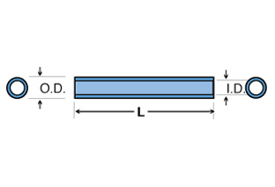
SEAMLESS TUBES | OD, MM | ID, MM | L, MM
SMALLEST | 5 | 2 | 50
LARGEST | 50 | 40 | 200
(图片586)

2) CUPS
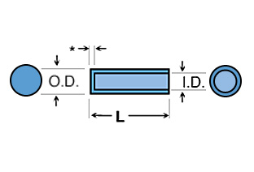

CUPS | ID, MM | OD, MM | L, MM
MIN. | 1 | 3 | 3
MAX | 40 | 50 | 500

（图片598）

