UHMW-PE POROUS FILTER
1. MATERIAL: UHMW-PE POWDER
2. TECHNICAL DATA:
1) FILTER GRADES: 0.50μm - 80μm
2) POROSITY: 30%- 60%
3) WORKING TEMPERATURE: 80℃ MAX.
4) COMPRESSIVE STRENGTH: 6.5MPa Max.
5) PRESSURE DROP: 1MPa MAX.
6）ALLOWABLE WORKING ENVIRONMENT: ACID, ALKALI, HIGH TEMPERATURE (80℃)
3. FORMING SHAPES:
1) SEAMLESS TUBES
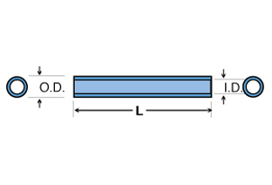
SEAMLESS TUBES | OD, MM | ID, MM | L, MM
SMALLEST | 20 | 14 | 50
LARGEST | 100 | 80 | 3600
JOINT TYPE: M20, M30, M40, 215,220,222,226, 228,other joints as requests
图片288.292

2) DISCS
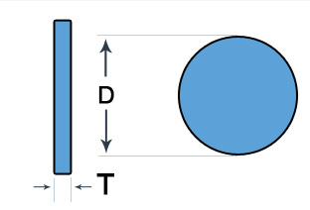

DISCS | DIAMETER, MM | THICKNESS, MM
MIN. | 2 | 1
MAX. | 1000 | 30

图片608

3) SHEETS
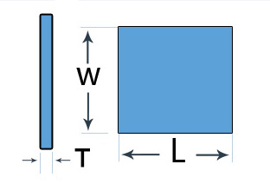

SHEETS | LENGTH, MM | WIDTH, MM | THICKNESS, MM
MIN. | 2 | 2 | 1
MAX | 1500 | 800 | 30

图片599

4) CUPS
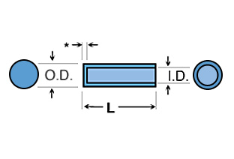

CUPS | ID, MM | OD, MM | L, MM
MIN. | 1 | 3 | 3
MAX | 200 | 250 | 500

（图片298）

